# Durable Furnitures

Interlude Home

## Morgan Shaker Chair - Floor Model

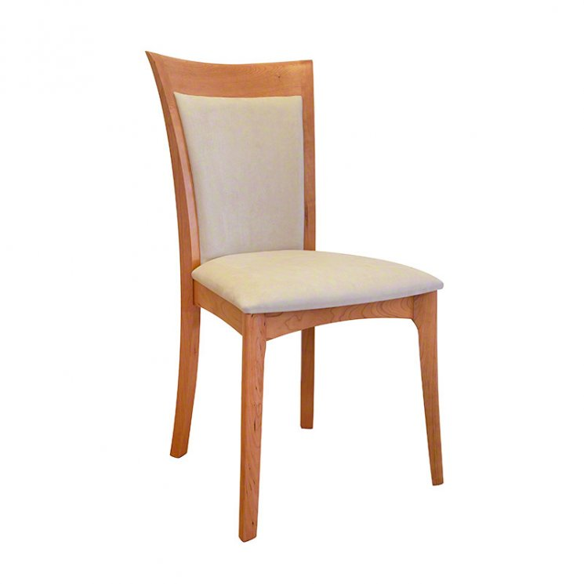

The Shaker style Copeland Sarah Morgan dining chairs in solid American Black Cherry with plush microfiber upholstered back and seat. Comfortable Shaker dining chairs available in side or arm chair style, designed to wear well with highly durable and luxurious polyester fabric. Best in its class of authentic custom fine dining furniture, this fully upholstered dining chair is destined to be a cherished family heirloom!